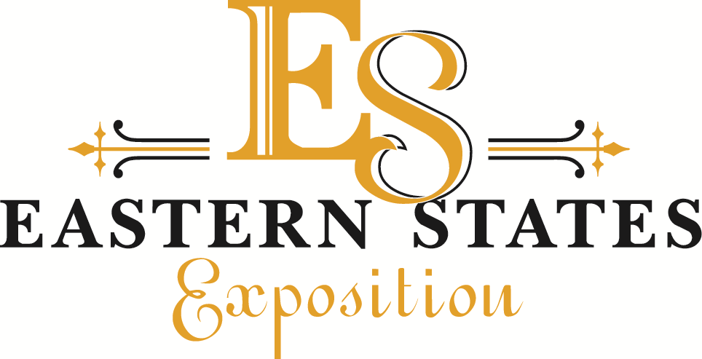

Non-Agricultural Commodity (Retail) Credentials

Order deadline August 1. Orders postmarked after August 1 will be ready after 10am on opening day. Additional credentials will not be available for purchase during The Big E.

Submit Completed Form, and Payment (Payable to Eastern States Exposition) to:

Eastern States Exposition
Attn: Derryl Bohaboy
1305 Memorial Avenue
West Springfield, MA 01089

Unless you plan with your Building Manager for credential pickup,
credential pickup will only be

Wednesday, August 26 – Friday, September 11
Better Living Center’s Sales Office (Door 7) – 9am – 5pm

State Building:

Vendor Name:

Phone Number:
Ticket and Parking:
Single-Day Exhibitor Ticket ($10) = $

17-Day Exhibitor Badge ($70) = $

Gate 1 - One-Day Parking ($10) = $

Gate 1 - 17-Day Parking ($170) = $
Total Due = $

Remember, there is an opportunity to park off site at one of the free shuttle parking lots (see attached maps) and board a shuttle. These shuttles drop off at Gate 1 for Gate 1 exhibitors. This opportunity helps with the frustration of parking at Gate 1, and it's free.
When boarding the shuttle, you need to show your Photo ID badge or single-day admission ticket showing your exhibitor’s name. We encourage exhibitors and their employees to take advantage of these free shuttles. The shuttles run from 6am continuously throughout the day and evening of The Big E. It's a great opportunity!!

